How to deploy EFOA solution on website

1. Insert columns in website database table prefix_user_attributes. It’s better to do that through phpMyAdmin or other web-based MySQL management tool.

`twitter` varchar(255) NOT NULL,

`facebook` varchar(255) NOT NULL,

`instagram` varchar(255) NOT NULL,

`pinterest` varchar(255) NOT NULL,

`linkedin` varchar(255) NOT NULL,

`youtube` varchar(255) NOT NULL,

`shop` varchar(255) NOT NULL,

`discipline` text NOT NULL,

`biography` text NOT NULL,

`cv` text NOT NULL,

`highlight_image` varchar(255) NOT NULL,

`summary` text NOT NULL,

`openhouse_host` tinyint(1) NOT NULL DEFAULT '0',

`openhouse_exhibiting` tinyint(1) NOT NULL DEFAULT '0',

`openhouse_number` int(10) NOT NULL DEFAULT '0'

1. Create plugin with name efoaprofile and content from here <https://github.com/Kookabura/efoa/blob/master/core/components/efoaextender/elements/plugins/plugin.efoaprofile.php>

Enable the following list of plugin events:

* OnBeforeManagerPageInit
* OnDocFormSave
* OnMODXInit
* OnUserSave

You should get the following view 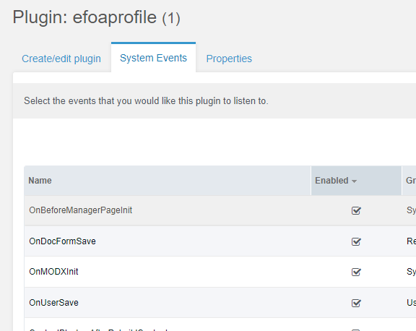

1. Copy file <https://github.com/Kookabura/efoa/blob/master/core/lexicon/en/efoa.inc.php> to core/lexicon/en/efoa.inc.php
2. Create media source for user profiles files <http://demo.tolkit.top/manager/?a=source> with the following parameters

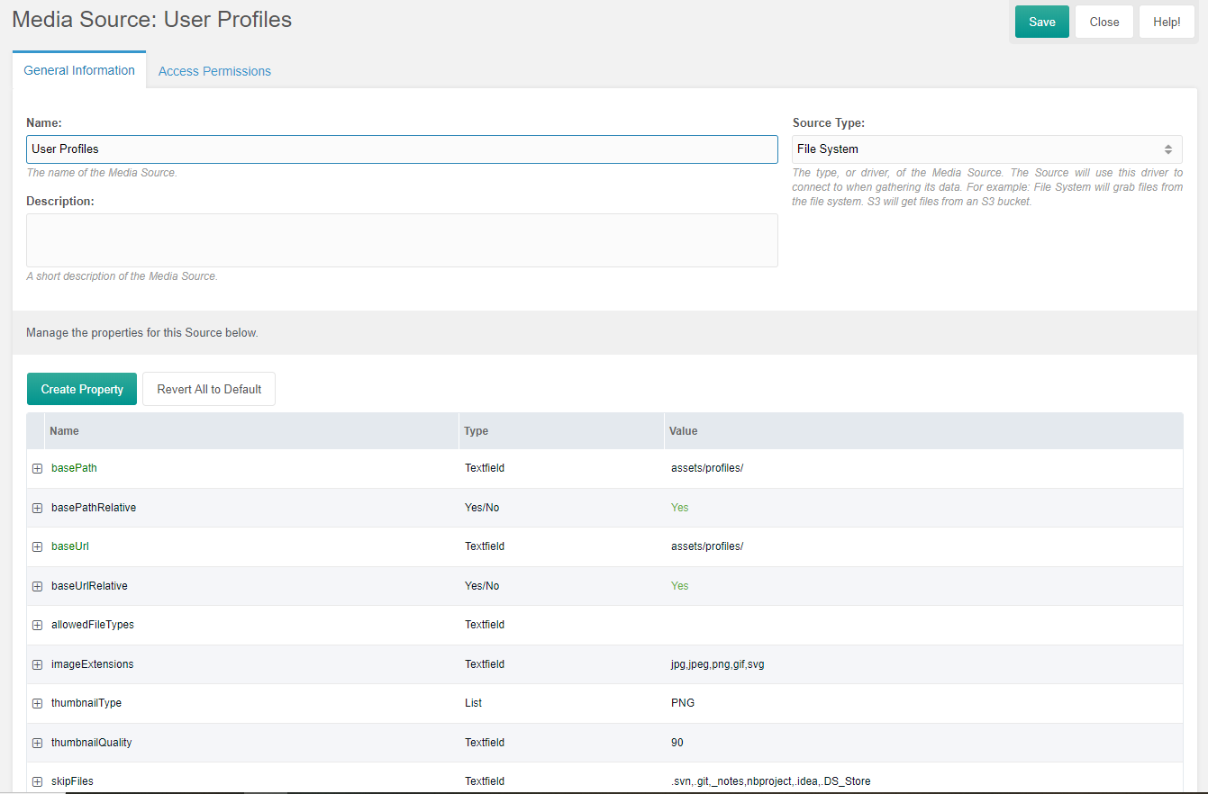

1. Import Access Policies from here <https://github.com/Kookabura/efoa/tree/master/core/components/efoaextender/elements/policies> to Access Policies

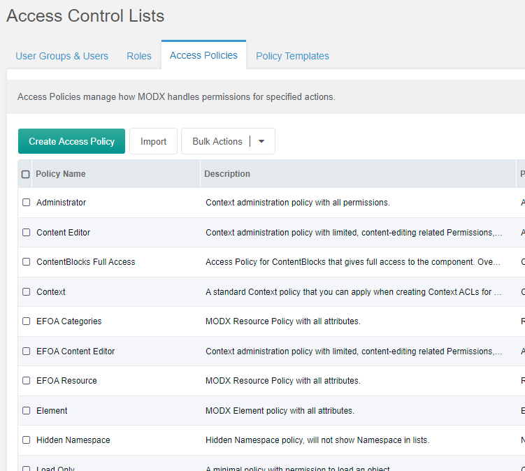

1. Create New User Group with name ‘EFOA Content Editor’ here <http://demo.tolkit.top/manager/?a=security/permission>. It should be the group with ID 2. This ID is used in efoaprofile plugin.

Add default_media_source setting for that group. The value should be the id of Media source that we’ve created in stage 4.

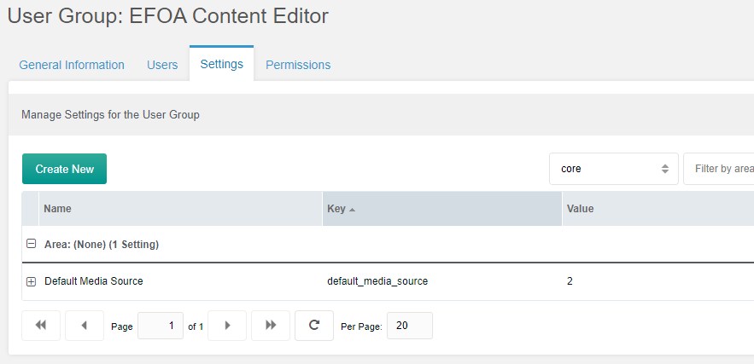

Add permission for group on Permissions tab. Permissions for Redactor, MoreGallery, ContentBlocks are created automatically on components installation.

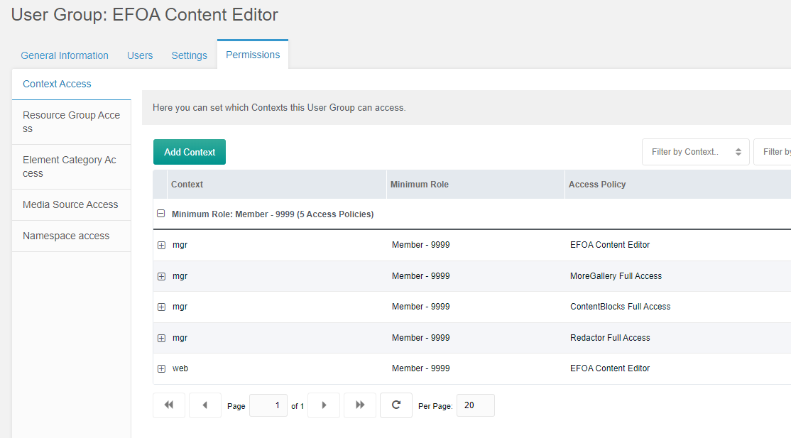

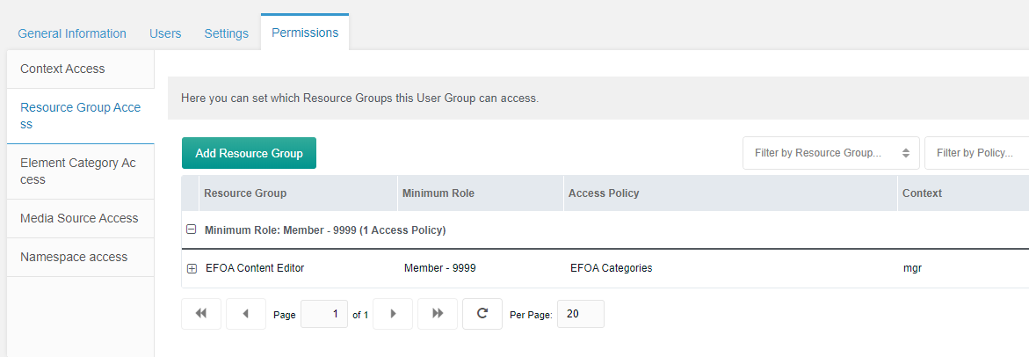

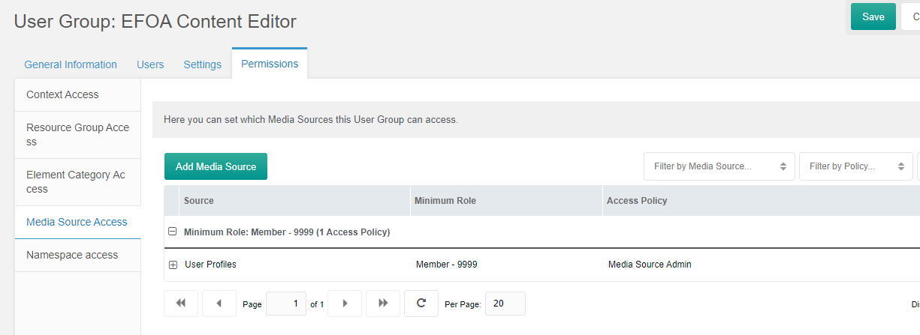

1. Set up Administrator group permissions

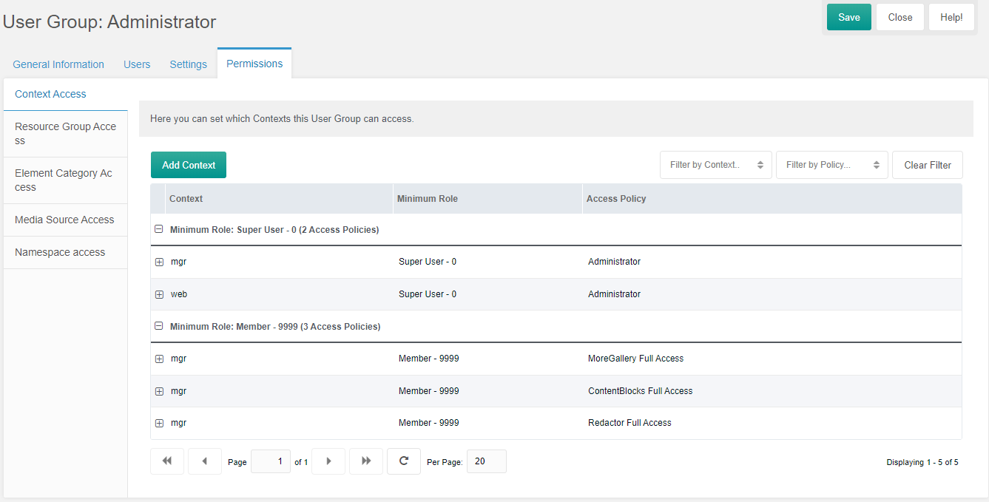

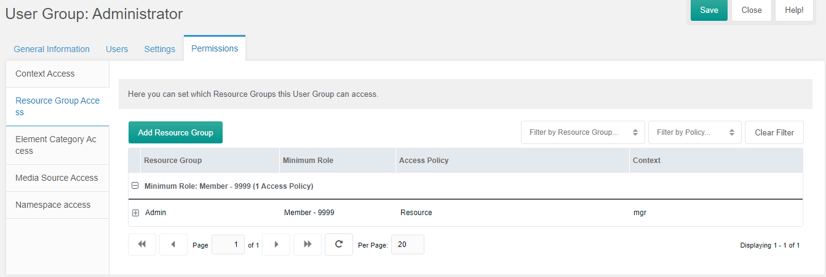

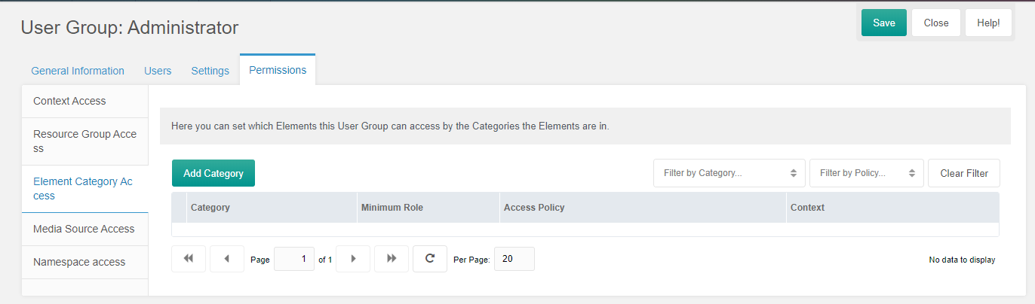

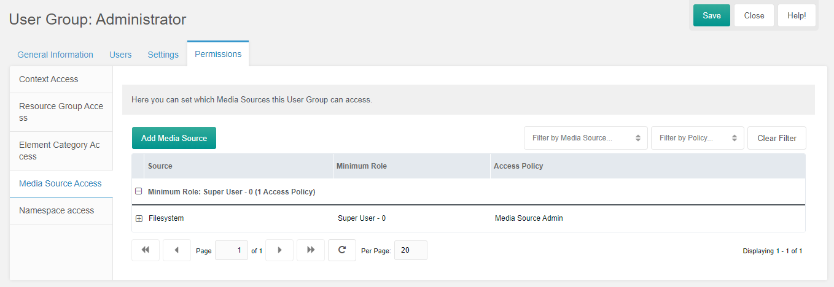

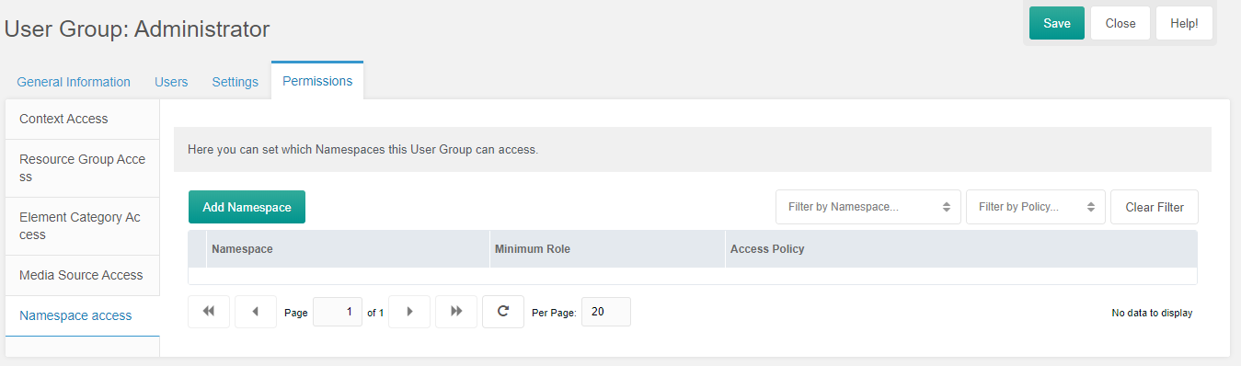

1. Set up Anonymous group Permissions

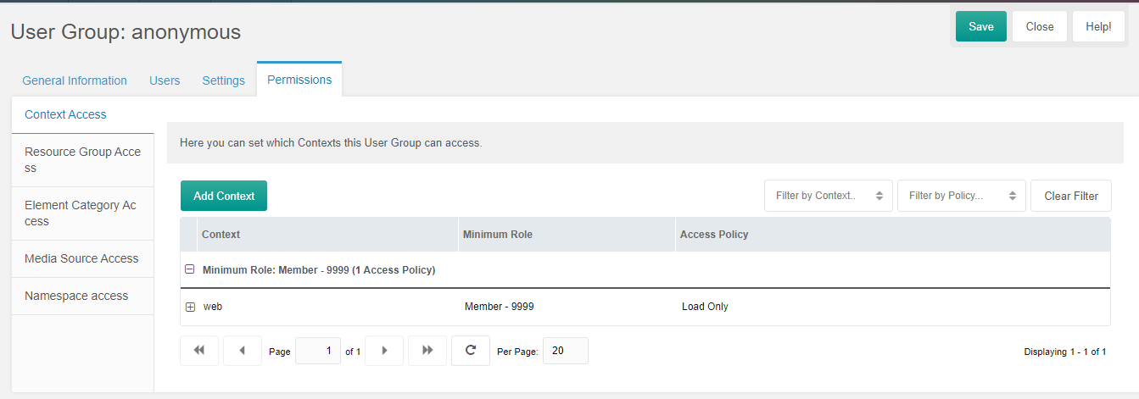

1. Create resource groups <http://demo.tolkit.top/manager/?a=security/resourcegroup>

Admin

This group should be created first. Its ID uses efoaprofile plugin.

All resources should be added in that group. Fir newly created resources it happens automatically. For those that were created earlier you should do that manually.

EFOA Content Editor

Add here Events, Galleries, Blog, Artists parent resources.

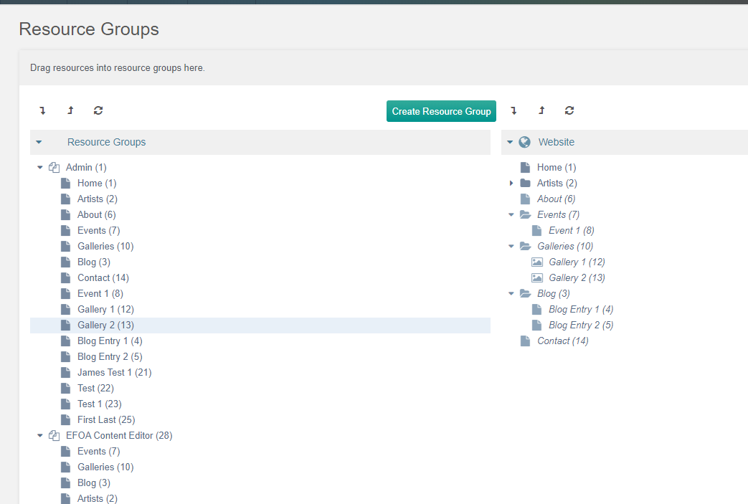

1. For hiding alias field for users import Manager Customization rules.

Open URL <http://demo.tolkit.top/manager/?a=security/forms>. Create New Profile EFOA Users.

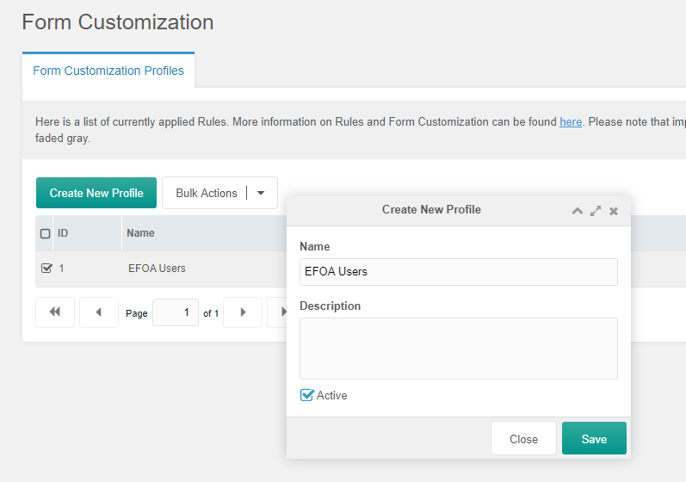

Add filer by group

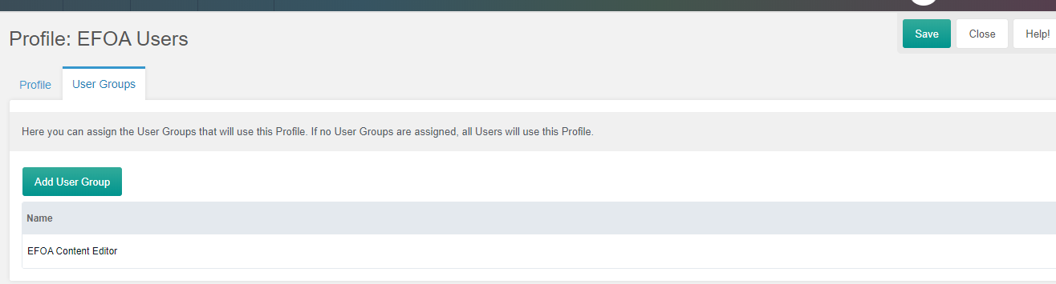

Import XML rules from file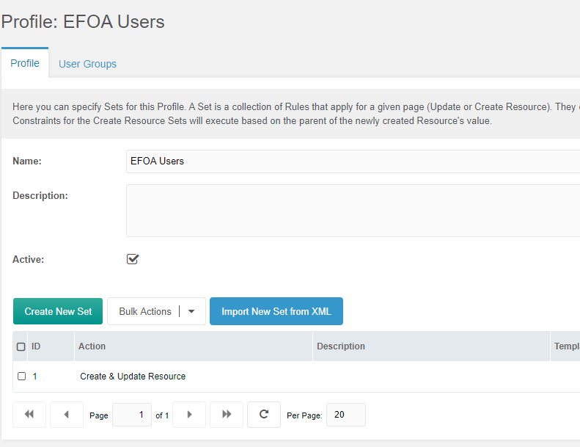

After that non-admin user will not see alias field in Manager.

1. For using bulk user import install Console from modstore.pro and copy script <https://github.com/Kookabura/efoa/blob/master/core/components/console/files/import_users.php> to it.
2. You can use csv template file for user import <https://github.com/Kookabura/efoa/blob/master/public_html/assets/files/users.csv>
3. Install Redactor, ContentBlocks, MoreGallery and other components.

## How to hide field in user profile

For hiding field comment field block with its label in efoaprofile plugin. Example <https://github.com/Kookabura/efoa/blob/master/core/components/efoaextender/elements/plugins/plugin.efoaprofile.php#L161-L173>

Some fields are mentioned twice in file. The first time is for user profile page, the second is for admin profile update page.

It the field is mentioned twice then you should comment is in two places of efoaprofile plugin.

## How to grant user access to resources in Events, Blog, Galleries

* Open a resource that you need to grant access to.
* Open Resource Groups tab
* Tick checkbox opposite user resource group. It should the one with profile_ prefix.
* Click Save.

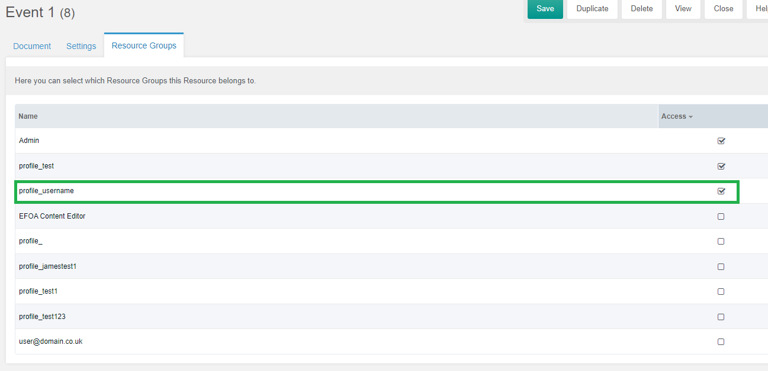

## How to get user fields on user page

Use pdoUsers with parameter users and filter by alias filed. Alias is the same as username.

Example:

{'pdoUsers' | snippet: [

'users' => 'test'

]}